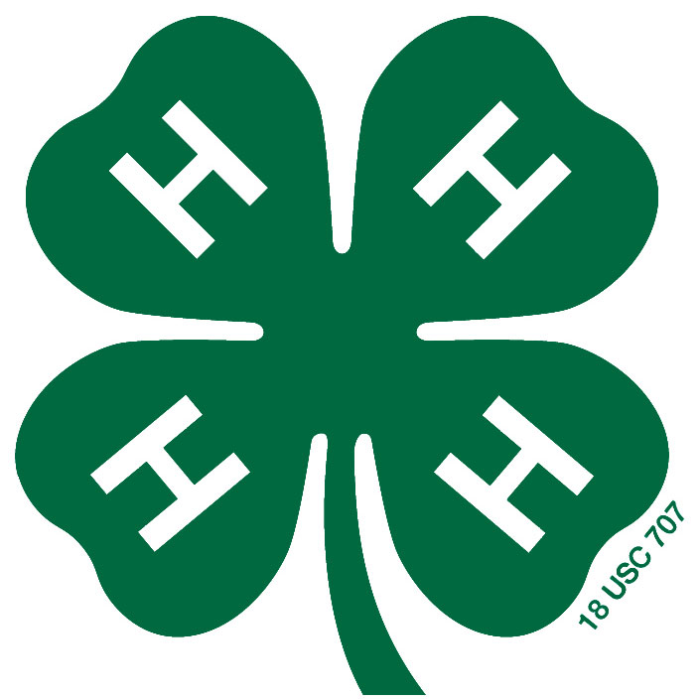
Central Kansas District 4-H Ambassador Application
Due September 30, 2022, 5 p.m. Either Extension Office
Name: Birth Date:
Address: City, State, Zip:
Email: Phone Number: ( )
Parent/Guardians Names:
4-H Club: Years in 4-H:
Year in School (8th grade and up): Name of School:
T-Shirt Size: Polo Shirt Size:
When does your 4-H Club meet (ex: 3rd Monday of the month @ 7 p.m.)?
Please answer the following questions, honestly, in the space provided.
Why do you want to be an Ambassador?

List and describe your public speaking experiences. (4-H and non 4-H)

Please describe your ability to work with people, handling responsibility and initiative. List experiences to support your description.

What has been your most rewarding 4-H experience and why?

List and describe your leadership experiences in 4-H and other organizations.

As a person of character who is trustworthy, responsible and fair, I have personally prepared this application to the best of my ability and certify that it accurately reflects my work. I will respect the judge’s final decision.

Applicant Signature: ________________________________ Date: ______________
If application is emailed, a typed signature will be accepted.

